Working of Linear induction motor:

Principle:

The basic principle of a linear induction motor is based on faraday’s laws of Electromagnetic induction which state that when a conductor is placed in a varying magnetic field an emf is induced across the conductor and if the conductor is a closed circuit, then induced current flows through it.

Operation:

A Linear induction motor has two parts a primary part and a secondary part. The primary part consists of a steel lamination stack with windings and Secondary is basically a sheet of aluminium with iron backing. The Primary part is kept movable while keeping the secondary fixed and vice versa can also be done. When the primary of a LIM is excited from a three phase ac supply, a travelling flux wave is produced which travels along the whole length of the primary. Now, as the secondary part is in contact with the primary part the travelling flux cuts the secondary part due to which an induced current flows along the secondary part. The direction of the induced current is decided in accordance with Lenz’s law such That it will oppose the change which has produced it. Due to this relative motion between the travelling flux and the conductors, the induced current interacts with travelling flux and produces a linear force or a Thrust. This produces a rectilinear motion which is the main operation of Linear Induction motor.

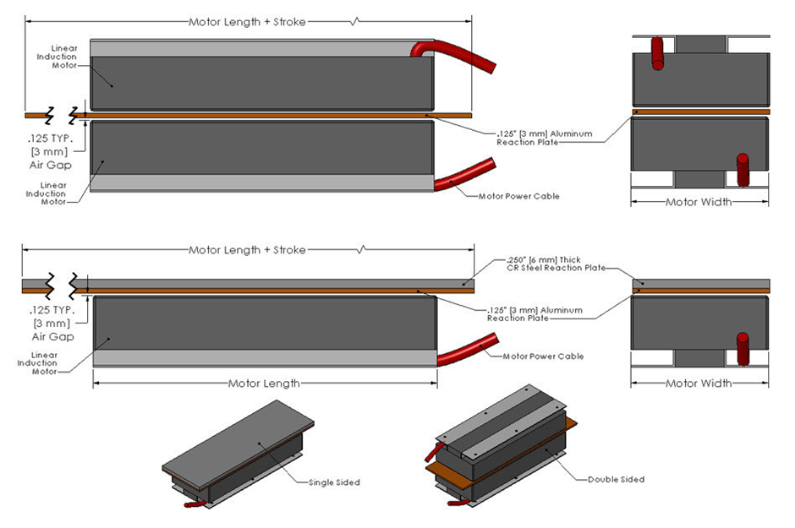

Important points from Working:

1. The synchronous speed Vs of the travelling flux is given by

Vs=2\*t\*fs

Where Vs=Linear synchronous speed

t=pole pitch

fs=frequency of the power supply.

1. The speed of the secondary in LIM is given by

Vr =Vs(1-s)

Where s is the slip.

Therefore, the slip is given by

s=Vs-Vr/Vs

1. The linear force F=air gap power/linear synchronous velocity (Vs)
2. Direction based on movable parts: -
3. Moving primary and fixed secondary:

The primary Winding is moving in the opposite direction of the travelling flux.

1. Moving secondary and fixed primary:

The secondary part moves in the same direction as the travelling wave. Hence the secondary winding is in the form of thin aluminium sheet.

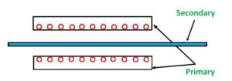

References:

1. <http://electricalarticle.com/linear-induction-motor-lim/>
2. <https://www.linearmotiontips.com/what-are-linear-induction-motors>
3. <https://electricalbaba.com/linear-induction-motor/>
4. Book-Electrical machines by Abhijit Chakrabarti and Sudipta Debnath.